**Bump Test Modeling**

**Topics Covered**

• First order transfer functions.

• Obtaining the QUBE-Servo 2 model using the bump test method.

• Model validation.

**Prerequisites**

• Integration laboratory experiment.

• Filtering laboratory experiment.

**1 Background**

The bump test is a simple test based on the step response of a stable system. A step input is given to the system and its response is recorded. As an example, consider a system given by the following transfer function:

*Y* (*s*)

*U* (*s*)

*K*

=

*τ s* + 1

(1.1)

The step response shown in Figure 1.1 is generated using this transfer function with *K* = 5 rad/V *−* s and *τ* = 0*.*05 s.

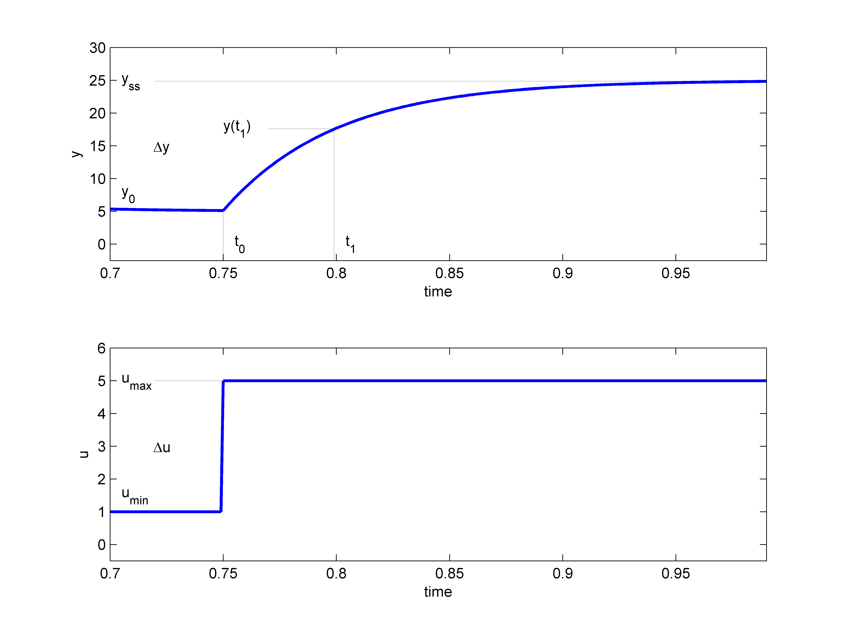

Figure 1.1: Input and output signal used in the bump test method

The step input begins at time *t*0 . The input signal has a minimum value of *umin* and a maximum value of *umax* . The resulting output signal is initially at *y*0 . Once the step is applied, the output tries to follow it and eventually settles at its steady-state value *yss* . From the output and input signals, the steady-state gain is

∆*y*

*K* = (1.2)

∆*u*

where ∆*y* = *yss − y*0 and ∆*u* = *umax − umin* . The time constant of a system *τ* is defined as the time it takes the system to respond to the application of a step input to reach 1 *−* 1/*e ≈* 63*.*2% of its steady-state value, i.e. for Figure 1.1

where

*t*1 = *t*0 + *τ,*

*y*(*t*1 ) = 0*.*632∆*y* + *y*0 *.* (1.3)

Then, we can read the time *t*1 that corresponds to *y*(*t*1 ) from the response data in Figure 1.1. From this, the model time constant can be found as:

*τ* = *t*1 *− t*0 *.* (1.4)

**1.1 Applying this to the QUBE-Servo 2**

Going back to the QUBE-Servo 2 system, the s-domain representation of a step input voltage with a time delay *t*0

is given by

*Vm* (*s*) =

*Av e*(*−st*0 )

*,* (1.5)

*s*

where *Av* is the amplitude of the step and *t*0 is the step time (i.e. the delay).

The voltage-to-speed transfer function is

Ω*m* (*s*) = *K*

(1.6)

*Vm* (*s*)

*τ s* + 1

where *K* is the model steady-state gain, *τ* is the model time constant, Ω*m* (*s*) = *L* [*ωm* (*t*)] is the load gear rate, and

*Vm* (*s*) = *L* [*vm* (*t*)] is the applied motor voltage.

If we substitute input Equation 1.5 into the system transfer function Equation 1.6, we get:

Ω*m* (*s*) =

*K Av e*(*−st*0 )

*.* (1.7)

(*τ s* + 1)*s*

We can then find the QUBE-Servo 2 motor speed step response in the time domain *ωm* (*t*) by taking inverse Laplace of this equation

*ωm* (*t*) = *K Av* (1 *− e*(*−*

*t−t*0

*τ* + *ωm* (*t*0 )*,* (1.8)

))

noting the initial conditions *ωm* (0*−* ) = *ωm* (*t*0 ).

**2 In-Lab Exercises**

Based on the VIs already designed in QUBE-Servo 2 Integration and Filtering labs, design a VI that applies a 2 V

step to the motor and reads the servo velocity using the encoder as shown in Figure 2.1.

To apply your step for a 2.5 seconds, set the *Final Time* of the Simulation Loop to 2.5 (instead of *Inf* ). Using the saved response, the model parameters can then be found as discussed in Section 1. As shown in Figure 2.1, the bumptest response is ”saved” using the Collector block from the *Control & Simulation* | *Simulation* | *Utilities* palette and displayed in an XY Graph. LඉඊVIEW™ graphs (as opposed to charts) have cursors that can be used to take measurements.

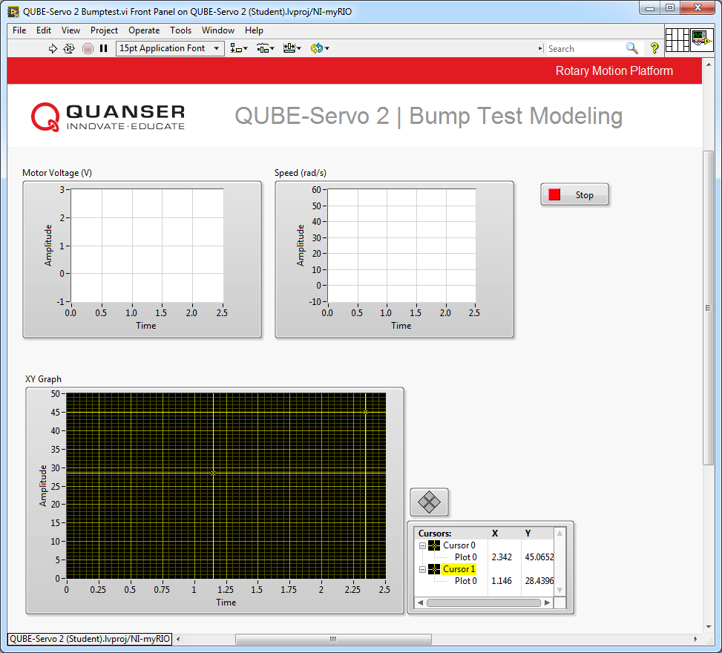

(a) Front Panel

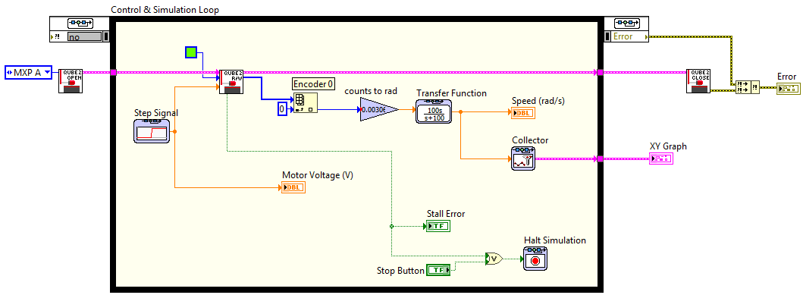

(b) Block Diagram

Figure 2.1: Applies a step voltage and measures corresponding servo speed

1. Run the VI to apply a 2 V step to the servo. The response should be similar to Figure 2.2.

2. Plot the motor speed response and the input voltage. For example, you can right-click on any of the waveform charts and select *Export* | *Export Simplified Image* to save the measured load/disk speed and motor voltage to a bitmap image file and attach that to your report.

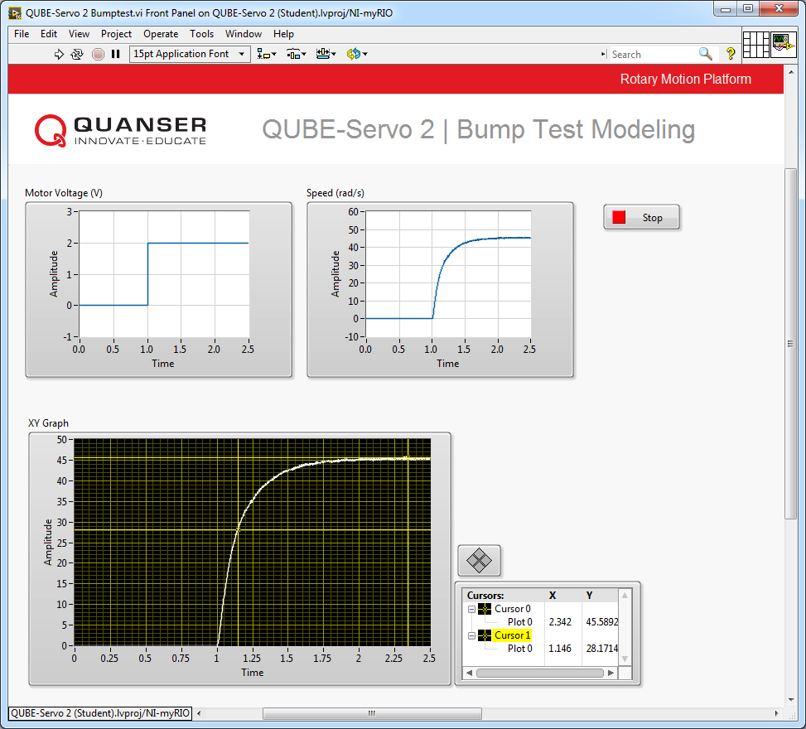

Figure 2.2: QUBE-Servo 2 Bump Test Response

3. Find the steady-state gain using the measured step response.

**Hint:** Use the *Cursor* palette in the XY Graph to measure points off the plot.

4. Find the time constant from the obtained response.

5. To check if your derived model parameters *K* and *τ* are correct, modify the VI to include a Transfer Function block with the first-order model in Equation 1.1, as shown in Figure 2.3. Display both the measured and simulated QUBE-Servo 2 responses in one waveform chart (using a Bundle function from the *Programming*

| *Cluster, Class, & Varient* palette). Run the VI. Attach a figure displaying both the measured and simulated response in one plot, as well as in the input voltage.

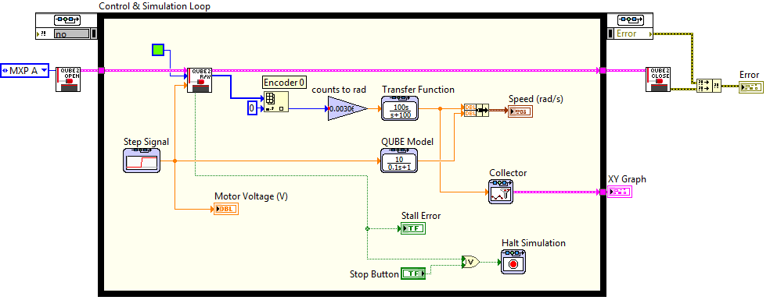

Figure 2.3: Validating bump test model

6. Did you derive the model parameters *K* and *τ* correctly? Explain.

7. Click on the Stop button to stop the VI.

© 2017 Quanser Inc., All rights reserved.

Quanser Inc.

119 Spy Court

Markham, Ontario

L3R 5H6

Canada

[info@quanser.com](mailto:info@quanser.com)

Phone: 1-905-940-3575

Fax: 1-905-940-3576

Printed in Markham, Ontario.

For more information on the solutions Quanser Inc. offers, please visit the web site at:

[http://www.quanser.com](http://www.quanser.com/)

This document and the software described in it are provided subject to a license agreement. Neither the software nor this document may be used or copied except as specified under the terms of that license agreement. Quanser Inc. grants the following rights: a) The right to reproduce the work, to incorporate the work into one or more collections, and to reproduce the work as incorporated in the collections, b) to create and reproduce adaptations provided reasonable steps are taken to clearly identify the changes that were made to the original work, c) to distribute and publically perform the work including as incorporated in collections, and d) to distribute and publicly perform adaptations. The above rights may be exercised in all media and formats whether now known or hereafter devised. These rights are granted subject to and limited by the following restrictions: a) You may not exercise any of the rights granted to You in above in any manner that is primarily intended for or directed toward commercial advantage or private monetary compensation, and b) You must keep intact all copyright notices for the Work and provide the name Quanser Inc. for attribution. These restrictions may not be waved without express prior written permission of Quanser Inc.